**ASSIGNMENT-2**

**Yaswanth Yarlagadda**

**99999-2918**

**PART-1:**

§ **Question 1.1**: Explain the three tiers or layers of the "layered data architecture" discussed within the first 10 minutes in the podcast. What are these three tiers and what are examples from each tier? You may use the table below to fill in your answer:

**Answer:**

| **Layer Name** | **Example of this layer** |
| --- | --- |
| Api | information from raw data |
| insight | algorithms/predictive techniques |
| AI driven layer | Reasoning/decision making |

§ **Question 1.2**: There was a discussion of a micro server approach to data analytics and data science. Please explain why such micro servers are considered a positive development in analytics (as discussed within the podcast).

**Answer:** micro servers are dedicated to performs single task. When there are dedicated micro services for each task the predictions are more accurate.

§ **Question 1.3**: Explain how personalized marketing is improving predictive recommendation? This answer should not to exceed more than a few words, so don't overthink what is being asked here.

**Answer:** The user is asked a series of questions based on which recommendations are shown according to their interests.

§ **Question 1.4**: Give one example of how the financial services industry is taking advantage of the advances in machine learning and predictive analytics?

**Answer:** It helps in speeding the payments and helps in the speeding of the complex decision

processes.

**PART-2:**

§ **Question 2.1** (3 points): Use the payoff table above:

* Draw the decision tree for the above table.

**Answer:**

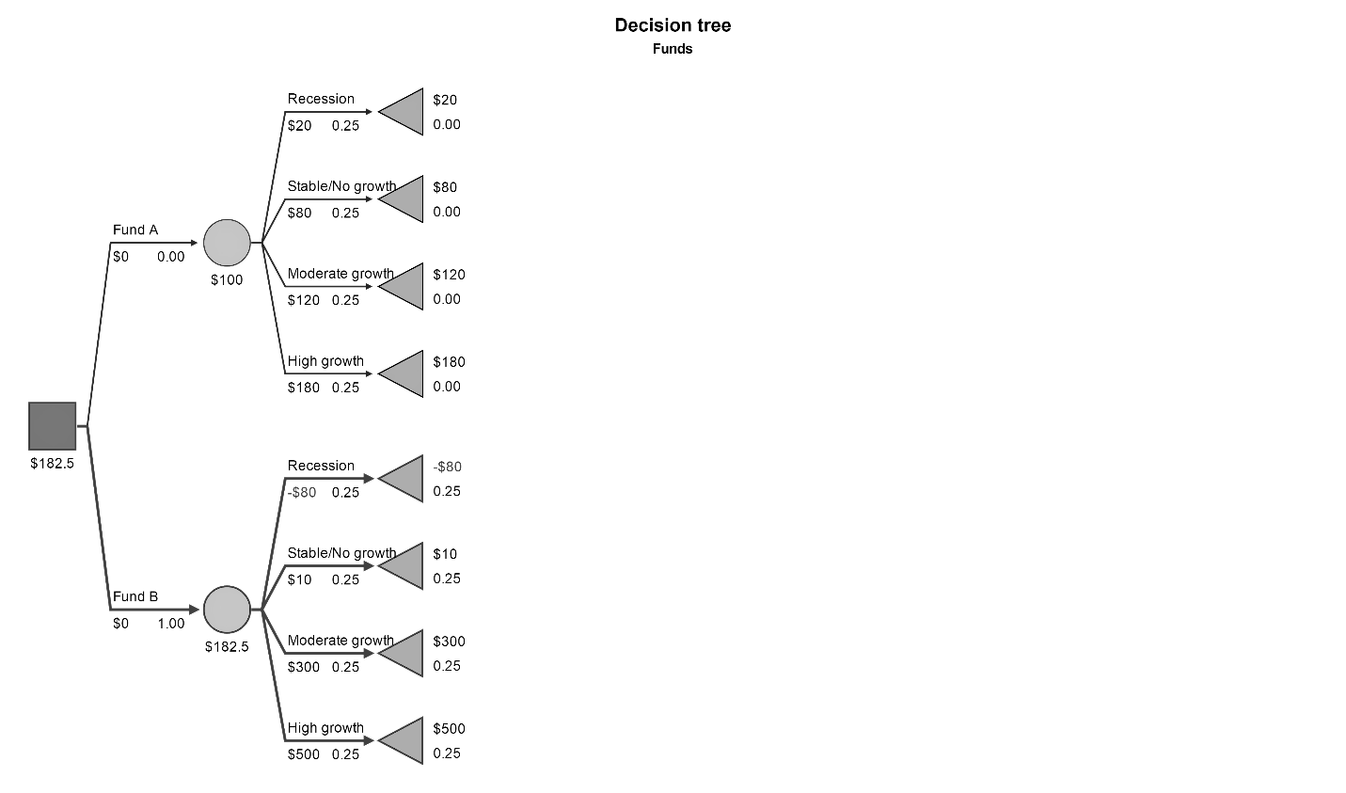

§ **Question 2.2** (1 point):

* What is the expected payoff of the minimax strategy?

**Answer:** The expected payoﬀ of the minimax strategy is **70**

§ **Question 2.3** (1 point):

* What is the expected payoff of the maximin strategy?

**Answer:** The expected payoﬀ of the maximin strategy is **20**

**PART-3:**

§ **Question 3.1** (2 points):

Update and show your decision tree with the new probabilities.

**Answer**

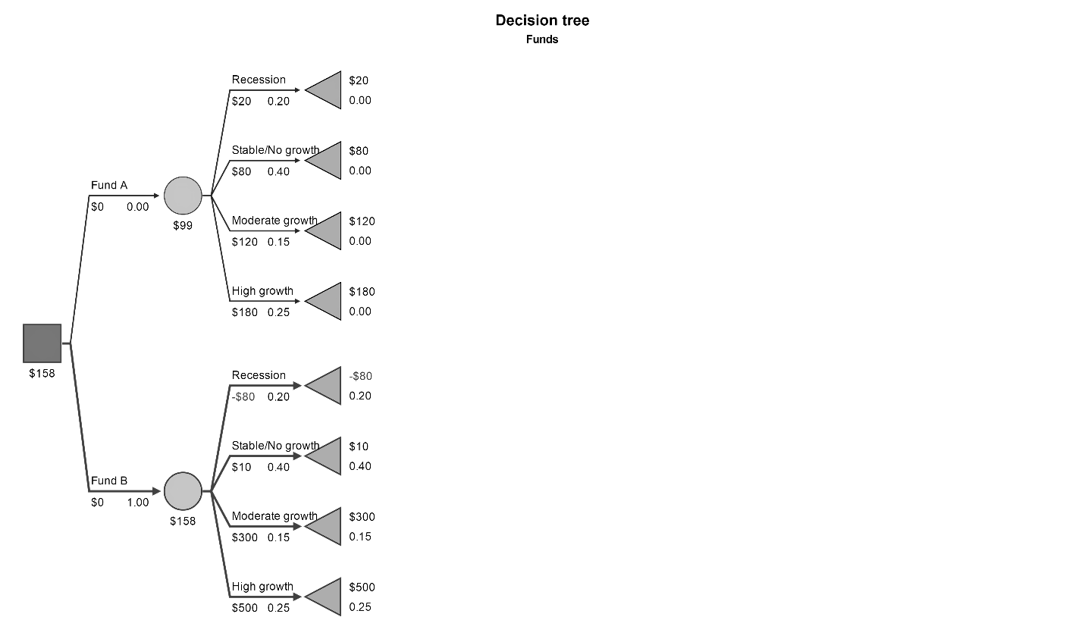

§ **Question 3.2** (1 point):

* What is the best strategy now given the probabilities if the investment team is optimistic about the next 2 quarters (recall the strategy that selects for high risk/high reward under optimism)?

**Answer:**

 If the investment team is positive about next two quarters then MAXIMAX is the best strategy